Exercise 4: MQTT Publish/Subscribe
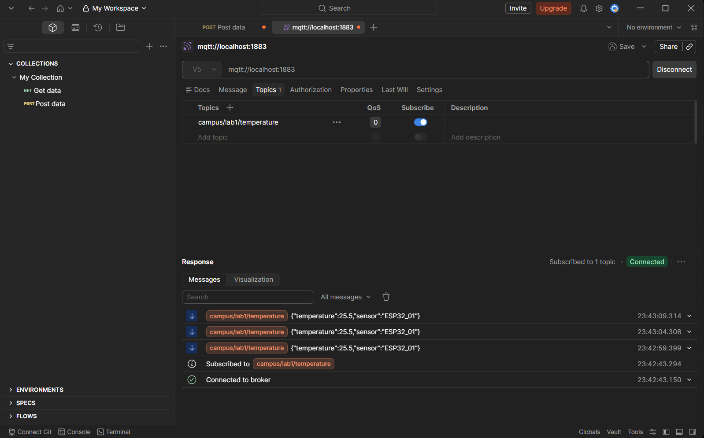
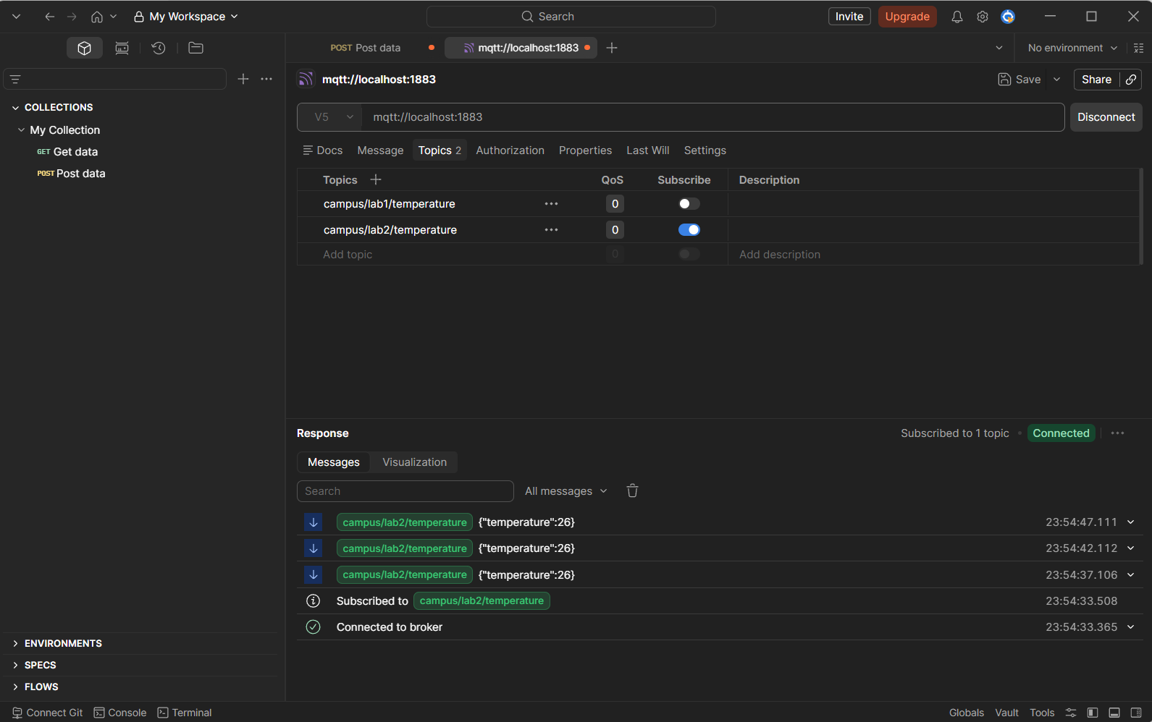
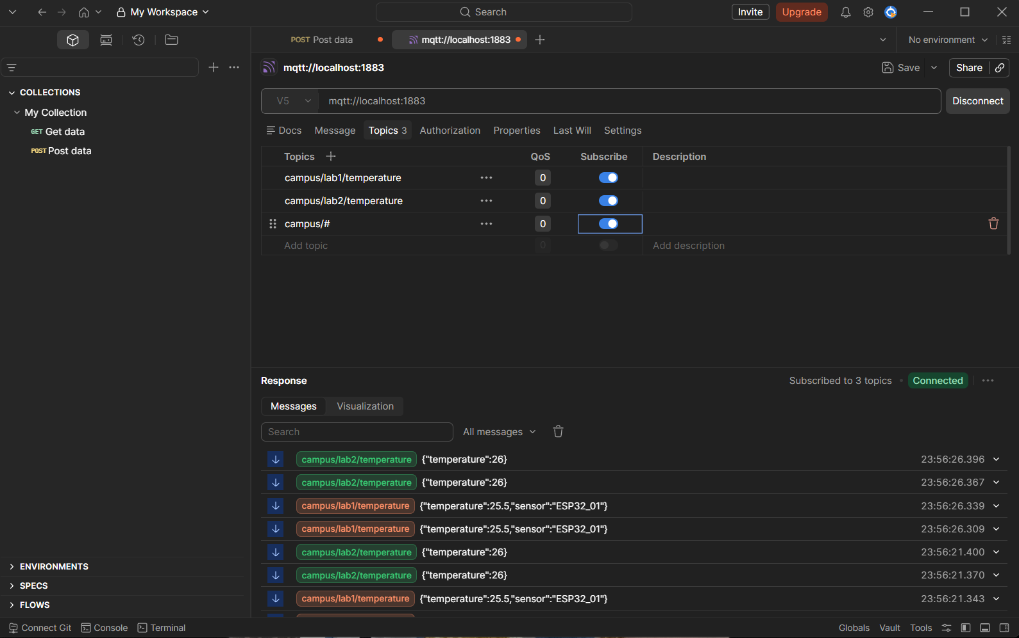

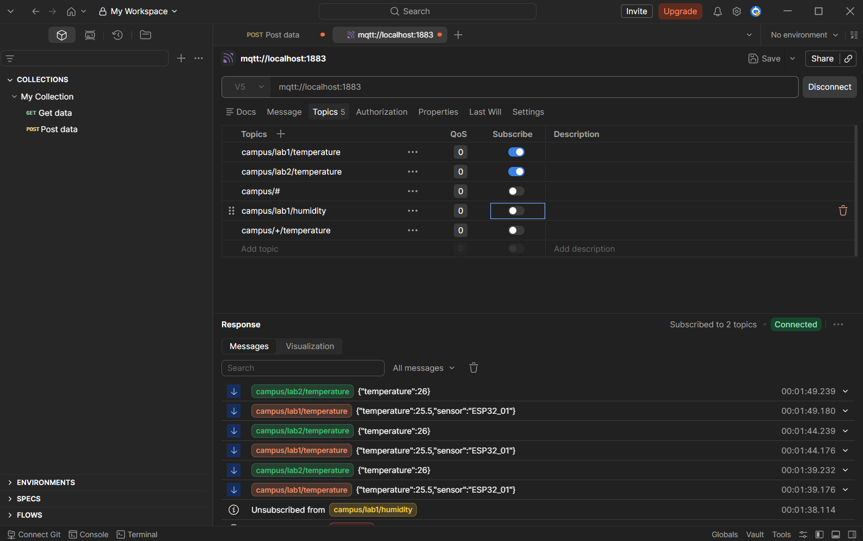

Step 5: Discussion Questions

Question 1: The Role of the Broker
In Week 3's HTTP, Postman directly "phoned" Node-RED (client-server), creating tight links. The EMQX broker is like a post office: Node-RED (publisher) drops messages there, Postman (subscriber) picks them up—no direct contact needed. MQTT wins over HTTP by decoupling devices for scalability, low power use in IoT, and handling many connections async (no polling).
Question 2: Publisher vs. Subscriber
Publishers send data to topics (e.g., Node-RED pushes temperature); subscribers listen to topics (e.g., Postman receives it). Yes, one device like ESP32 can do both—e.g., a smart thermostat publishes room temp while subscribing to remote "turn on" commands.
Question 3: Client vs. Server
Unlike HTTP (needs server always ready), MQTT broker stores messages if subscriber (Postman) goes offline (with QoS >0 and persistent session). Publisher (Node-RED) keeps sending; broker queues and delivers later when subscriber reconnects—no data loss.

Conlusion
MQTT brokers like EMQX decouple publishers and subscribers, enabling efficient many-to-many communication, unlike direct HTTP client-server setups. Topic hierarchies with wildcards (# for multi-level, + for single-level) organize data flexibly for real-world sensor networks.

